KraussMaffei focuses on customer experience and digital technology at FIP 2022
- "Modernize your technology" is KraussMaffei's motto at FIP in Lyon, France (April 5-8, 2022; Hall 6, booth M05/N08)
- Digital solutions such as Social Production and LiveCare are at the core of the company’s presentation
- Frédéric Falmer appointed as new Digital and Service Solutions Director of KraussMaffei France

Lyon, April 5, 2022. KraussMaffei teams will be present at FIP, the trade fair for the Plastics, Composites & Rubber industry in France from April 5 to 8, 2022 in Lyon. Digitalization has accelerated the transformation of the market. Therefore, for the first time, KraussMaffei has chosen not to exhibit any machine on its booth. This exhibition will therefore be an opportunity for the plastics pioneer to highlight all the digital solutions offered to its customers.

"Our objective is to highlight our service solutions. Therefore, we have chosen to present an entirely digital stand at the FIP where no machines will be exhibited. The show is a unique opportunity for us to strengthen the links with our customers through presentations and exchanges with our experts", explains Christophe Longuet, President of KraussMaffei Group France. The solutions presented at FIP will also largely develop the theme "Making plastics more circular" to maximize yield, ensure product quality, reduce life cycle costs and ensure sustainability.

Large displays will showcase innovative solutions developed by KraussMaffei, enabling increased machine productivity, higher quality, and lower production costs. These new solutions provide real added value through the customer's integral and coordinated control of the machine fleet and online remote access from KraussMaffei experts.

Industry 4.0 and digital transformation have become a reality
In particular, customers and visitors will have the opportunity to experience the "SocialProduction" web and mobile app at FIP 2022, which helps optimize the production of injection molding machines. This new KraussMaffei application combines the advantages of social networks and advanced technologies for better production monitoring: the machines inform users live in secure chat groups.

SocialProduction automatically identifies deviations in the production flow, bringing machine monitoring into a new era.
LiveCare is KraussMaffei's new solution for remote maintenance management based on information sent by the machine. Seamlessly integrated into SocialProduction, wear and tear conditions are monitored and visible at all times.

KraussMaffei is thus resolutely committed to a digital approach that will bring more service to its customers. KraussMaffei has just reinforced its management team with the arrival of Frédéric Falmer, ex ArcelorMittal digital transformation leader, as Digital and Service Solutions Director for KraussMaffei France.

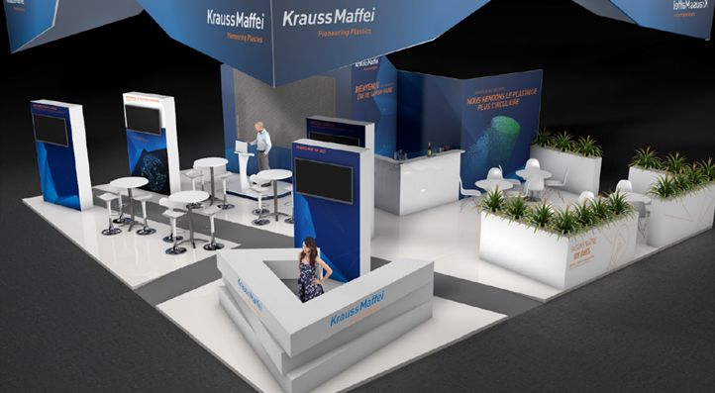
KM_PR_20220404_FIP 22 Booth layout.jpg
Photo: KraussMaffei
Enclosure: Pictures and more information can be found at
www.kraussmaffei.com

Press contact:

Christophe Longuet
President KraussMaffei Group France
Phone: +33 7 60 61 30 69
Email: christophe.longuet@kraussmaffei.com

Uli Pecher
Head of Corporate Communications
Phone: +49 (0) 89 8899 1080
Email: Uli.Pecher@kraussmaffei.com

KraussMaffei – Pioneering Plastics
KraussMaffei is among the world’s leading manufacturers of machinery and systems for the production and processing of plastics and rubber. Our brand stands for cutting-edge technologies – for more than 180 years. Our range of services covers all areas of injection molding machinery, extrusion technology and reaction process machinery. This gives KraussMaffei a unique selling point in the industry. With the high innovative power of our standardized and individual product, process, digital and service solutions, we can guarantee customers sustained additional value over the entire value-adding chain. Our range of products and services allow us to serve customers in many sectors including the automotive, packaging, medical and construction industries, as well as manufacturers of electrical and electronic products and household appliances. KraussMaffei employs around 4.700 people all over the world. With more than 30 subsidiaries and over 10 production plants, as well as about 570 commercial and service partners, we are represented internationally close to our customers. Since its foundation in 1838, the company’s headquarters have been in Munich.
In April 2016, the Chinese state-owned company China National Chemical Corp. Ltd. (“ChemChina”), one of the leading chemical companies in China, became the majority shareholder of KraussMaffei Group. At the end of 2018, ChemChina listed the KraussMaffei Group as KraussMaffei Company Ltd. in Shanghai. The listing opened up access to the Chinese capital market and local investors.
For more information: www.kraussmaffei.com

